IMS Trap Capacity
(To be used with ‘TUN - QRZ - IMS Trap Capacity (Corrected TIC)’ feature file)

DRE Setup
- Add the following line to the ‘method_setup.lua’ file...
Typhoon\config\scripts\method\method_setup.lua:

SetupTICCorrection()

- Set diagnostics to true within the ‘TrapCapicaityFeedbackDRE.lua’ file...
Typhoon\config\scripts\method\DataProcessors\TrapCapacityFeedbackDRE.lua:

Diagnostics = true

- Set diagnostics to true within the ‘CorrectedTIC.lua’ file...
Typhoon\config\scripts\method\DataProcessors\CorrectedTIC.lua:

Diagnostics = true

- Enable the logging of EPC connection diagnostics to a text file
(e.g. within TTERM PRO Save to log)

- Run an HD method custom tune (e.g. HDMS.xml) to check EPC (TTERMPRO) logging is working...
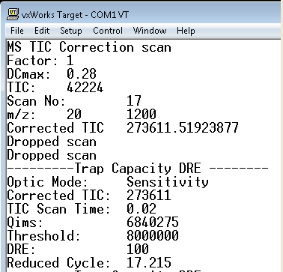

- Add the following lines (in blue) to the ‘CorrectedTIC.lua’ file...
Typhoon\config\scripts\method\DataProcessors\CorrectedTIC.lua: 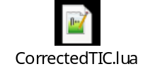

-- Lua global variable set as 'scan' as Message::ScanData type

--initialise
function init()
Diagnostics = false
DCmax = 0.28
DREMAX = 99.8
end

--on scan data - process scan data
function ondata()

if (scan:header():is_tof() == false) then
print("ERROR: incorrect HD data type for Corrected TIC scan")
return
end

-- send scan to the host
SendScan(scan)

scan:header():set_drop_scan(true)

local scanDRE = DREMAX
if (scan:settings():stats():has_dre() and
scan:settings():stats():dre() > 0
and scan:settings():stats():dre() <= DREMAX) then

end

local factor = DREMAX / scanDRE
local corectedTIC = factor * utility:get_corrected_tic(scan, DCmax)

processor:set_corrected_tic(corectedTIC)

if (Diagnostics) then
print("MS TIC Correction scan")
print("Factor:", factor)
print("DCmax:", DCmax)
print("TIC:", scan:header():tic())
print("m/z:", scan:header():startmass(), scan:header():endmass())
print("scan no:", scan:header():scan_number())
print("Corrected TIC", corectedTIC)
end
end

function SendScan(scanData)

local scanCopy = utility:copy_scan_data(scanData)
scanCopy:header():set_function_key(1)
processor:send_scan(scanCopy)
end

This will allow to save TIC Survey scan into the raw folder.

Checking the Calculated value is Correct
- Run ‘C:\Waters Corporation\Typhoon\config\methods\hdms.xml’ from a sample list:
Typhoon\config\methods\SampleList.xml: 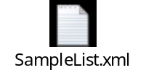

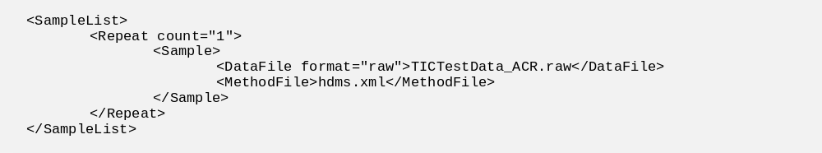

- The sample list can be started by running the following from a batch file, or CMD prompt...

CD ”C:\Waters Corporation\Typhoon\config\methods”

”C:\Waters Corporation\Typhoon\bin\Waters.Test.MethodRunnerClient.exe” -sl SampleList.xml

- Create a ‘readdata.bat’ batch file (details below) and copy to the Typhoon folder.
Typhoon\readdata.bat: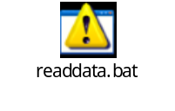

bin\WatersRawReader.exe -r "C:\Waters Corporation\Typhoon\data_store\TICTestData_ACR.raw" -o "C:\Waters Corporation\Typhoon\data_store\TICTestData_ACR.txt" -f "1" -s "0" -e "10" -i "false"

where:

-f "1" is command to specify raw function number
-s "0" -e "10" is commands to specify start and end scans
-r is to specify raw folder location
-o is to specify output file name with text content

- Run the batch file. This will create a TXT file in the data_store folder... 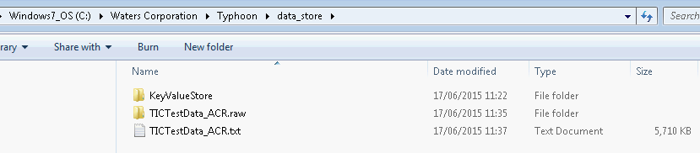

...which contains the text data:
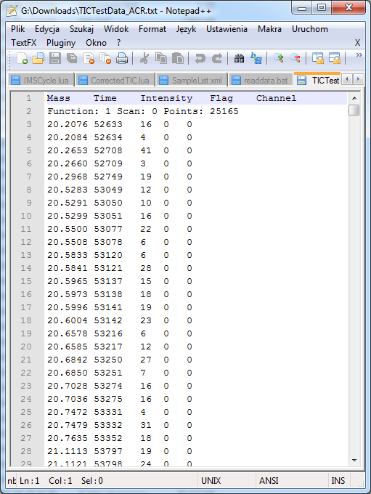
- Paste the data for Function 1 Scan 0 to the following Spreadsheet...
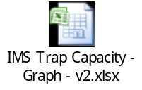
NOTE: Within the spreadsheet there are various values that will need to be updated...
a). MZmax - this is the ‘High Mass’ value from the HDMS.xml method
b). Dcmax - this value is output from the EPC logging (TTERM PRO)
c). Scan DRE - this value is output from the EPC logging (TTERM PRO)
d). Setting Scan Time - this value is output from the EPC logging (TTERM PRO) when the following command is enabled
enableFastnetScanTimeDiagnostics
NOTE: DRE Factor and Scan Time Factor are calculated and should not be manually updated.

IMPORTANT: This spreadsheet will generate a Combined TIC Sum value. This should be the same value that was output in the TTERMPRO EPC log (for Scan 0)...
EPC log
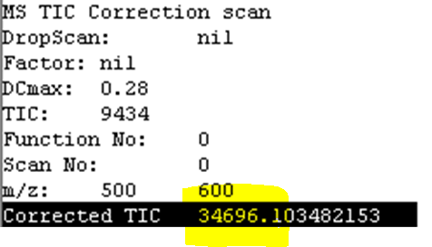

Spreadsheet


Check that these values match

(NOTE: because the excel sheet and c++ rounding are slightly different , values may vary around +/- 1.0)

TIC Threshold Levels
Single Functions.
- Modify the hdms.xml method to add a TIC threshold.
<?xml version="1.0"?>
<MsMethod InstrumentType="QTof" InstrumentModel="Osprey" Version="1.0">
<Function Type="HDMS" TimeStart="0.0" TimeEnd="60.0">
<Instance>
<Settings>
<Setting Name="CorrectedTICThreshold" Value="5000000.0"/>
<Setting Name="StartMass" Value="50.0"/>
<Setting Name="EndMass" Value="1200.0"/>
<Setting Name="ScanTime" Value="0.5"/>
<Setting Name="InterscanDelay" Value="0.005"/>
</Settings>
</Instance>
</Function>
</MsMethod>

- Monitor the following parameter in Engineering Dashboard. TWAVE2_TRAP_FILL_TIME_SETTING

Determining the Full Scale ‘TWAVE2_TRAP_FILL_TIME_SETTING’ value (HD DRE = 100%)
Set the beam intensity low (temporarily set the Tune page ‘Instrument’ tab ‘Detector Voltage’, or the ‘System 1’ tab ‘Entrance’ value to zero) to find the full scale ‘TWAVE2_TRAP_FILL_TIME_SETTING’ value

NOTE: previous tests have indicated a value of 15.62 is normal for a mass range of 1000. A ‘TWAVE2_TRAP_FILL_TIME_SETTING’ value of 15.62 represents an HD DRE of 100%
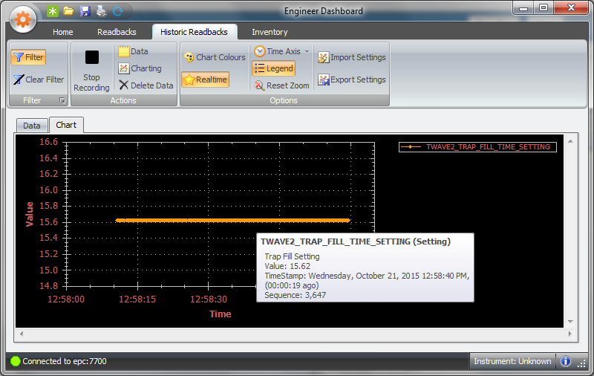

Run the single function HDMS.xml method and the TWAVE2_TRAP_FILL_TIME_SETTING should drop from its full scale value. If not then try decreasing the CorrectedTICThreshold value in the method and running again. This will give you an indication of an appropriate value to use.

Multiple functions.
- Change the HDMS.xml method file to contain multiple functions that have different threshold levels. Set the CorrectedTICThreshold values in each function to attempt to change the DRE / TWAVE2_TRAP_FILL_TIME_SETTING to a different value for each function:
<?xml version="1.0"?>
<MsMethod InstrumentType="QTof" InstrumentModel="Osprey" Version="1.0">
<Function Type="HDMS" TimeStart="0.0" TimeEnd="60.0">
<Instance>
<Settings>
<Setting Name="CorrectedTICThreshold" Value="100000.0"/>
<Setting Name="StartMass" Value="50.0"/>
<Setting Name="EndMass" Value="1200.0"/>
<Setting Name="ScanTime" Value="0.5"/>
<Setting Name="InterscanDelay" Value="0.005"/>
</Settings>
</Instance>
</Function>
<Function Type="HDMS" TimeStart="0.0" TimeEnd="60.0">
<Instance>
<Settings>
<Setting Name="CorrectedTICThreshold" Value="50000.0"/>
<Setting Name="StartMass" Value="50.0"/>
<Setting Name="EndMass" Value="1200.0"/>
<Setting Name="ScanTime" Value="0.5"/>
<Setting Name="InterscanDelay" Value="0.005"/>
</Settings>
</Instance>
</Function>
<Function Type="HDMS" TimeStart="0.0" TimeEnd="60.0">
<Instance>
<Settings>
<Setting Name="CorrectedTICThreshold" Value="25000.0"/>
<Setting Name="StartMass" Value="50.0"/>
<Setting Name="EndMass" Value="1200.0"/>
<Setting Name="ScanTime" Value="0.5"/>
<Setting Name="InterscanDelay" Value="0.005"/>
</Settings>
</Instance>
</Function>
</MsMethod>

NOTE: Again, if the TWAVE2_TRAP_FILL_TIME_SETTING does not drop from its previous full scale value, then try reducing the threshold values. The change in DRE should be seen in the EPC log and the corresponding change in TWAVE2_TRAP_FILL_TIME_SETTING should be seen in Engineering Dashboard.
